**Electrical Fundamentals**

Name: _____________________________________

1. Which of the following graphs best represents an ohmic conductor? (1 mark)

Answer:

A B C D

2. A lightning bolt transfers 30.0 C of charge to the Earth through a potential difference of 2.00 × 108 V. The lightning strike lasts for a time of only 1.50 ms.

a. How much energy is dissipated in this lightning strike? (2 marks)

b. What is the average power delivered during the strike? (2 marks)

3. The element of an electric jug has a resistance of 47.6 Ω and draws a current of 5.25 A. 750 mL of water at a temperature of 18.0 °C is in the jug. How long will it take to bring the water to the boil (100 °C)? (3 marks)

4. The circuit diagram below shows a two-way switch wired to a single globe.

globe

Neutral

Active

Switch 1 Switch 2

With the switch positioned as shown, is the globe on or off? ___________ (1 mark)

5. In each circuit below, the batteries are identical and the resistances of the globes (W, X, Y,and Z)

are as shown. (2 marks)

**Rw = 2 Ω Rx  = 2 Ω Ry = 2 Ω Rz = 4 Ω**

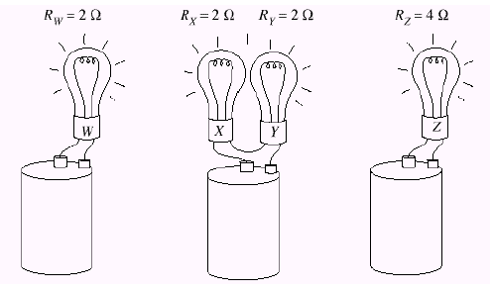

Write a statement that describes the relationship between the brightness of the globes.

_____________________________________________________________________________

_____________________________________________________________________________

_____________________________________________________________________________

_____________________________________________________________________________

6. Electric blankets are usually fitted with three heat settings:

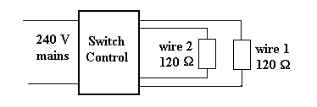

1. If only wire 1 is connected to the 240 V supply, what is the current from the supply? (2 marks)
2. If wires 1 and 2 are connected in series, what is the current drawn from the supply? (2 marks)
3. If wires 1 and 2 are connected in parallel, what is the current drawn from the supply? (2 marks)
4. Explain how the electric blanket can be operated on different heat settings. (2 marks)

_____________________________________________________________________________

_____________________________________________________________________________

__________________________________________________________________________________________________________________________________________________________

7. A student completes a circuit that includes a mystery box as shown below.

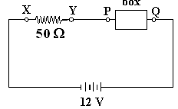

If the potential difference between *X* and *Y* is 8.0 volts, which of the following boxes (A - D) is in

the circuit? (2 marks)

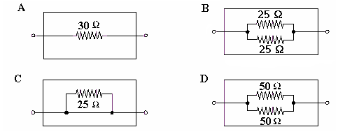

Answer

8. Three resistors, having resistances of 20 Ω, 30 Ω, and 50 Ω, are connected in series across a 12 V power supply. Calculate:

a. The total resistance. (1 mark)

b. The current flowing in each resistor. (1 mark)

c. The potential difference in the 30 Ω resistor. (1 mark)

The resistors are then connected in parallel. Find

d. The total resistance. (1 mark)

e. The current through the 30 Ω resistor. (1 marks)

9. An electrical engineer has set up the following circuit in an electrical device. Write your answers in the spaces provided for the following questions (show your working below).

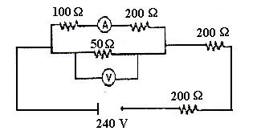

1. Determine the total resistance of the circuit. (2 marks) Answer: __________________

b. What is the reading on the voltmeter? (3 marks) Answer: __________________

c. What is the reading on the ammeter? (3 marks) Answer: __________________

**BONUS QUESTION.**

To the nearest 10 ohms, what is the value of the unknown resistor? The current in the 150 Ω resistor is 0.11834 A.

